Present Tense of Gustar with Infinitive Verbs
1. The infinitive form of the verb tells what’s happening. But unlike a conjugated verb, it doesn’t tell you who the subject is.

2. In Spanish, infinitives may have one of three endings:
-ar like in nadar = to swim -er like in correr =t o run -ir like in escribir = to write

3. Like nouns, infinitives are used after gustar to say what people like to do.
(A mí) me gusta patinar. = I like to skate (A él) le gusta comer. = He likes to eat.

4. Whenever you use gustar with an infinitive verb, the correct form is gusta (not gustan).
Me gustan los videos. = I like videos. (gustar is followed by a noun)
Me gusta alquilar videos. = I like to rent videos. (gustar is followed by a verb)
______________________________________________________________________________

Pronouns after Prepositions
1. Pronouns can stand for the same noun yet still have different forms, depending on how they’re being used in the sentence.


2. You already know subject pronouns and the pronouns used with gustar. Pronouns have a different form when they come after prepositions, such as a (to), de (of, from, about), con (with) and en (in, on, at).
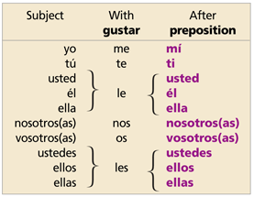

3. The pronouns mí and ti combine with con to make the special forms conmigo and contigo.

4. With gustar, the phrase formed by a and a pronoun can be added to a sentence to clarify or emphasize who likes something.

